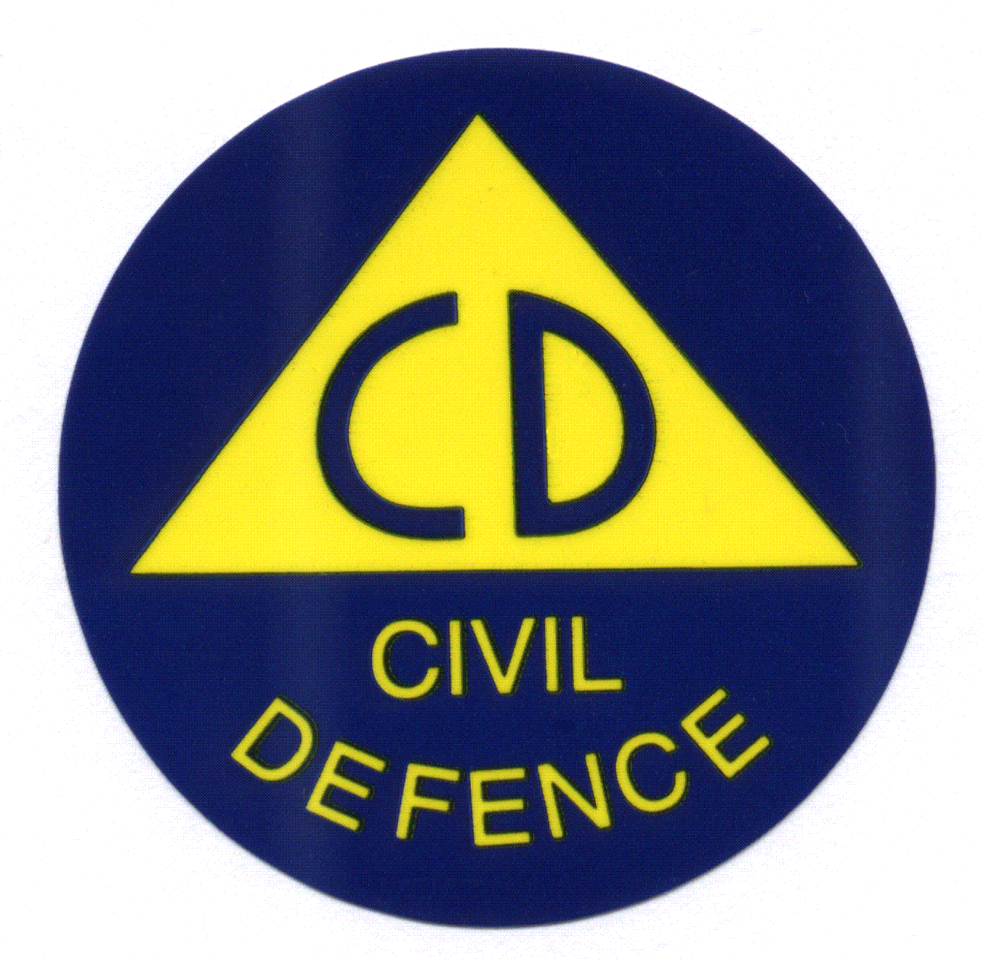
FAQs for Returning Home after Evacuations
Evacuated people, including people who have self-evacuated: Please make sure you register with Council 03 546 0200, or at the Trafalgar Centre, so we can contact you directly about your home.
Evacuated homes are being inspected to ensure they are safe.
By registering as an evacuee, it means we can let you know once a decision has been made about the status of your property following inspection.
Please wait to hear to hear from us before returning home – if we haven’t checked homes properly, the land could still be unstable.
Thank you for your patience and cooperation, we are working hard to get people home safely.

FREQUENTLY ASKED QUESTIONS
Q: How long till I can enter my home?
We are working as quickly as we can to get people home safely. We have a big task and inspecting for land instability is more complex than for flooding.
Please note the inspections are a two-stage process, after an initial rapid assessment for damage, a more detailed assessment involving geotechnical specialists and building consent officers follows.
Once both of those assessments have been undertaken if you are already registered with Council you will be called to let you know the situation for your property.
We are doing all we can to get these inspections done as quickly as possible, as we appreciate that the uncertainty of not knowing whether you will be able to return to your home is an anxious and unsettling situation. Building inspectors have arrived from around the country to assist in this job and we are extremely grateful for their mahi.
Q. Can I get through the cordon briefly to get stuff from my house?
We understand your frustration but it’s not safe for you or first responders. PLEASE respect cordons and evacuation zones. Areas with land instability need to be inspected by experts.
Q. I’ve been called and told my property has a red/yellow placard what does this mean?
If you have been told you have a red/yellow placard it means that sadly you cannot stay in your home at this time.
For YELLOW homes, you can still go in and get things you need. Take pictures (for insurance) and take your time, but you are unable to stay overnight due to the safety risks that exist.
For RED homes, we’re really sorry, but this home is not safe to enter at this time. Please contact your insurer in the first instance.
For YELLOW, these restrictions remain until either a building officer inspects your property and changes the colour of the placard, or you have completed any remedial work identified in a Detailed Damage Evaluation (building or land stability). A Detailed Damage Evaluation is the responsibility of the property owner. You should contact your insurance company to discuss this.
Q. What if my home is damaged?
A. If you are able to (i.e. if your house has no placard or a yellow placard), you should take photos of all damage and speak to your insurance company as soon as possible.
There will be insurance experts at the Incident Information Centre daily from 8:30am - 6:30pm if you prefer to speak to someone in person.
Q. Where can I go to for help?
A. The Incident Information Centre is open from 8:30am – 6:30pm daily, at the old iSite building Millers Acre Centre, Nelson (from Wednesday 24 August).
Q. Is there someone I can talk to about insurance?
A. Yes- there will be insurance experts daily at the Incident Information Centre to talk to you kanohi ki te kanohi (face to face). You can also call your insurance company if you prefer.
You should be taking photos and talking to their insurer as soon as you can.
Q. Can I get cash from the Mayoral Relief Fund?
A. The Fund will be open to any resident, ratepayer, business owner and not-for profit organisation in Nelson or Tasman regions that has suffered financial hardship as a result of the weather event.
Details about how to apply will be made available soon.
Q. Can I get an emergency MSD payment?
A. You may be eligible. MSD will be at the Incident Information Point daily or you can
call 0800 559 009.
Q. Who can I talk to about my animals?
If you have left animals have at home after evacuating, please contact MPI (0800 00 83 33) or SPCA (03 547 7171) for assistance as soon as possible.
Please don’t try to go through cordons to get animals who’ve been left behind. Our furry friends tend to seek a safe place and if home feels weird, they may have gone somewhere else.
Q. How long will we be in a state of emergency?
A. At this stage, we are in a state of emergency until at least Wednesday 31 August. Basically, it just means Civil Defence have certain powers to make things happen to preserve community safety in an emergency
Q: I am really stressed. Can I talk to someone?
Yes, you can call or text 1737 for 24/7 for confidential support.
Q: What cultural or tikanga support is available before I re-enter my property?
Pou awhina (support people) are available should you wish to receive any advice or support regarding tikanga or cultural matters pertaining to your wellbeing and your property. Please advise our Iwi Emergency Management Rōpū if you do. You can either:
• Call Barney Thomas on 027 221 8918
• Or email: em.iwiliaison@ncc.govt.nz
Q: What other support is available for our Māori communities?
Please don’t be whakamā to ask for help. For hauora support, call Te Tauihu Māori health provider Te Piki Oranga on 0800 ORANGA ( 0800 672 642).
For general support, please call Te Kotahi o Te Tauihu Trust on 0800 514 358 or Whakatū Te Korowai Manaakitanga Trust on 03 547 5958.
You can also call the Whānau Ora navigators at your local marae or iwi office.

